JIRA EXPERIMENTS
EX NO : 1
Aim: Create a Kanban Board in Jira to visualize project workflow.
Tasks Added:
- Gather Requirements
- Design System Architecture
- Create Database Schema
- Develop User Interface
- Perform Testing
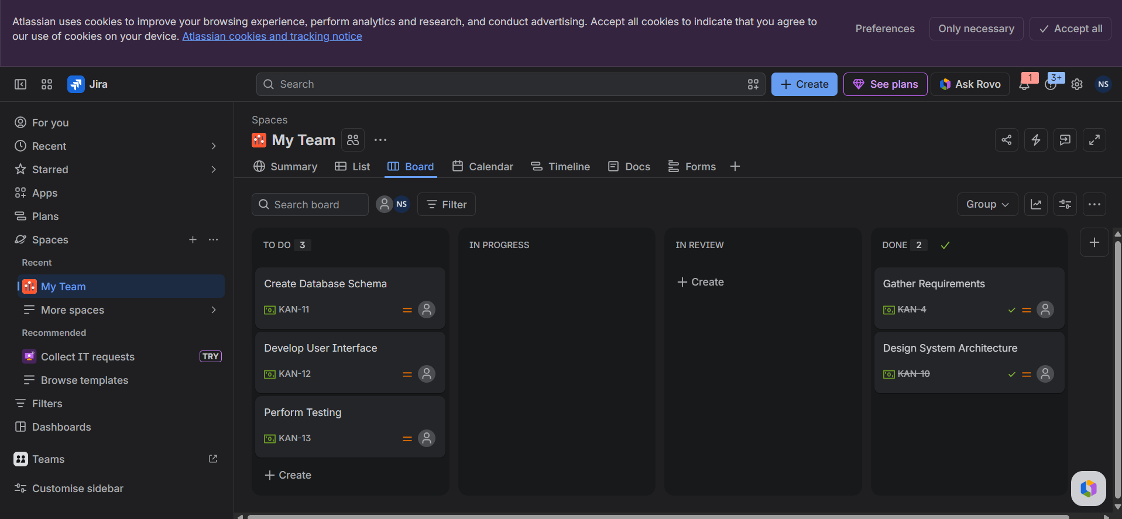
Workflow:
Tasks were moved from To Do → In Progress → Done to simulate project progress.
Result:
A Kanban board was successfully created and task movement across workflow stages was demonstrated

EX NO : 2 Scrum Project Management and Sprint Planning Using Jira

AIM
To create a Scrum Project in Jira, add and prioritize backlog items, create a one-week sprint, move backlog items into the sprint, start the sprint, and track the progress of tasks using the Scrum board.
PROCEDURE
- Log in to Jira Software and create a new Scrum project.
- Open the Backlog section of the project.
- Create at least five backlog items:
  - Create User Registration Page
  - Develop API for Login
  - Design Database Schema
  - Implement Password Encryption
  - Create User Dashboard
- Prioritize the backlog items by arranging them according to their importance.
- Create a new sprint and set its duration to one week.
- Move the prioritized backlog items into the created sprint.
- Start the sprint using the Start Sprint option.
- View the Active Sprint board to monitor the sprint tasks.
- Move tasks across the workflow columns (To Do, In Progress, and Done) to simulate sprint execution.
- Capture screenshots of the sprint board at the start and end of the sprint.

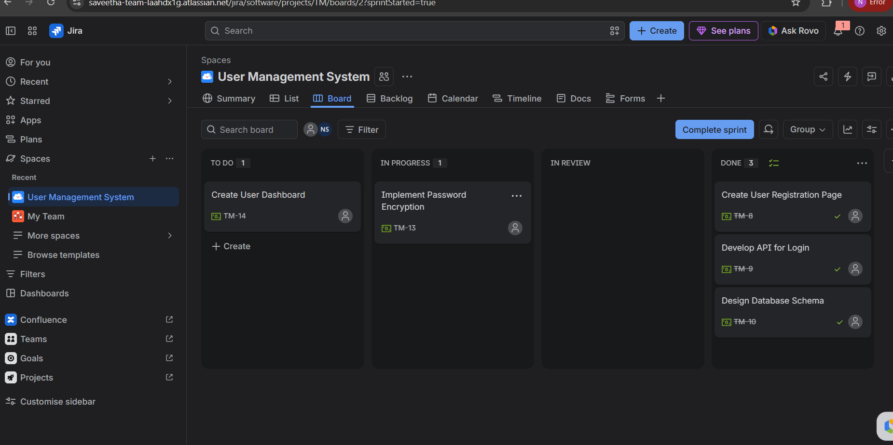

RESULT
A Scrum project was successfully created in Jira. Five backlog items were added and prioritized. A one-week sprint was created, backlog items were moved into the sprint, and the sprint was started successfully. The sprint board was used to track task progress by moving tasks through the To Do, In Progress, and Done stages, demonstrating the Scrum workflow effectively.

EX NO 3: Experiment: Jira & Confluence Integration for Project Tracking
Aim
To create a project management workflow by configuring Jira issues for a software project and embedding them into a Confluence overview page to track sprint progress and monitor task status in real-time.
Procedure
Part 1: Jira Project & Task Setup
- Log in to the Atlassian workspace and create a new project named Library-related tasks (Key: LRT).
- Create five core project issues/tasks in the backlog:
  - Develop Book Search Functionality
  - Create User Login Page
  - Implement Book Issue Module
  - Design Database Schema
  - Generate Fine Calculation Report
- Update the statuses of the tasks on the Kanban/Sprint Board as follows to represent progress:
  - Done: Develop Book Search Functionality, Create User Login Page
  - In Progress: Implement Book Issue Module
  - To Do: Design Database Schema, Generate Fine Calculation Report
Part 2: Confluence Page & Jira Integration
- Open Confluence from the Atlassian App Launcher and create a new blank page.
- Set the page title to Library Management System Project Overview.
- Add a brief project description summarizing the purpose of the system and how Jira is used for tracking development progress.
- Insert the Jira macro by typing /jira on a new line and opening the Insert Jira work items modal.
- Filter by the project Library-related tasks, select the 5 created issues (LRT-6 to LRT-10), and click Insert to embed the dynamic Jira table.
- Create a new section titled Sprint Progress.
- Insert a status badge using /status set to 40% (representing 2 completed tasks out of 5 total tasks) alongside the progress description.
- Click Publish to make the page live.

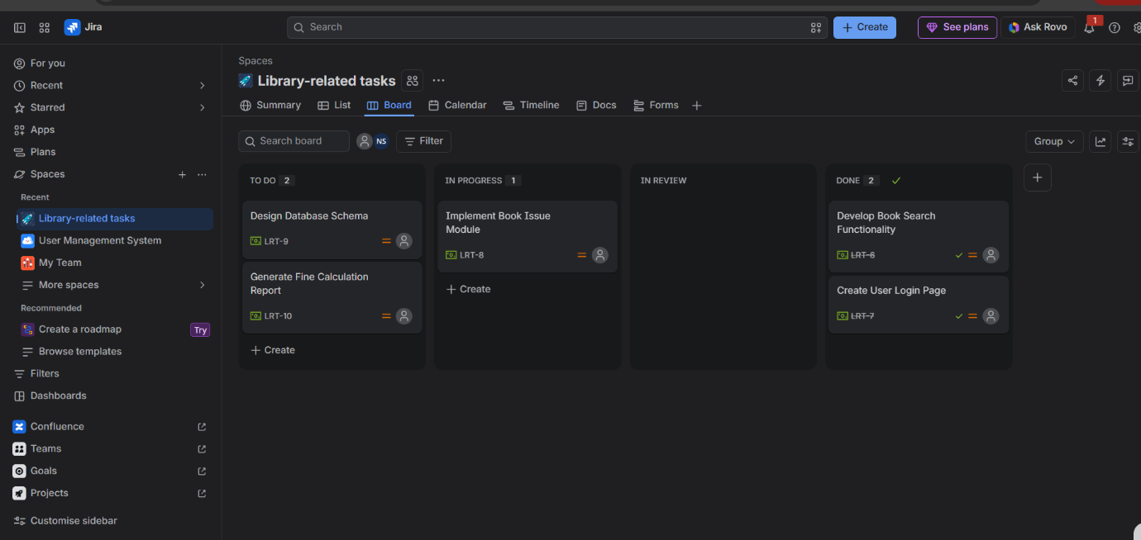
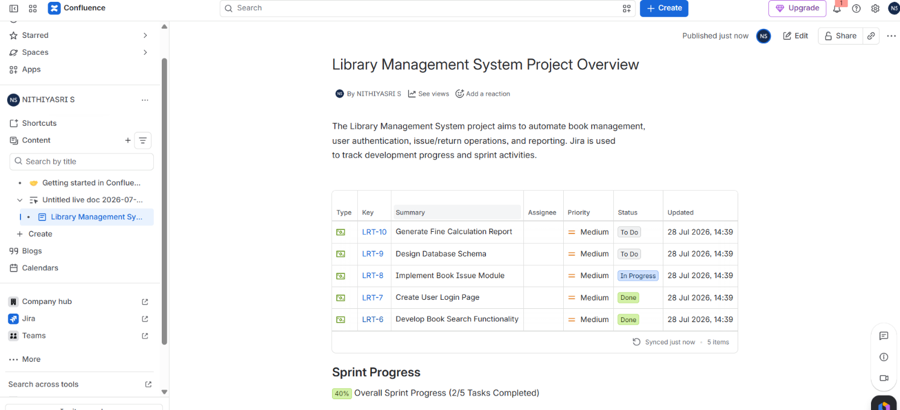

Result
The Library Management System Project Overview page was successfully created and published in Confluence. Live Jira issues were dynamically embedded showing real-time task statuses (To Do, In Progress, Done), and sprint progress was successfully monitored at 40% completion.

Exp No 4: Requirements Prioritization using MoSCoW and Kano Models
Aim
To prioritize the requirements of a Task Management System using the MoSCoW and Kano models in Jira for effective project planning and requirement management.
Procedure
- Project Setup:
  - Logged in to Jira Software and created a new project named Task Management System.
- Requirement Creation:
  - Created the following four requirements as Jira issues:
    - User Login and Role Assignment
    - Task Creation and Assignment
    - Task Prioritization and Deadlines
    - Progress Tracking and Reporting
- Sprint Backlog Configuration:
  - Opened the Backlog section and added all four issues to Sprint 1.
- MoSCoW Model Implementation (Via Jira Priority Field):
  - Configured and assigned the MoSCoW categories using Jira's priority scheme:
    - Must Have (must): User Login and Role Assignment, Task Creation and Assignment
    - Should Have (should): Task Prioritization and Deadlines
    - Could Have (could): Progress Tracking and Reporting
- Kano Model Implementation (Via Jira Labels):
  - Categorized the requirements against customer satisfaction levels using custom Jira labels:
    - Basic / Must-Be Needs (Kano-MustBe): User Login and Role Assignment, Task Creation and Assignment
    - Performance Need (Kano-Performance): Task Prioritization and Deadlines
    - Excitement / Attractive Need (Kano-Attractive): Progress Tracking and Reporting
- Backlog Arrangement & Verification:
  - Arranged the issues in the sprint according to their priority rankings and verified the finalized backlog, list view, and board items within Jira.

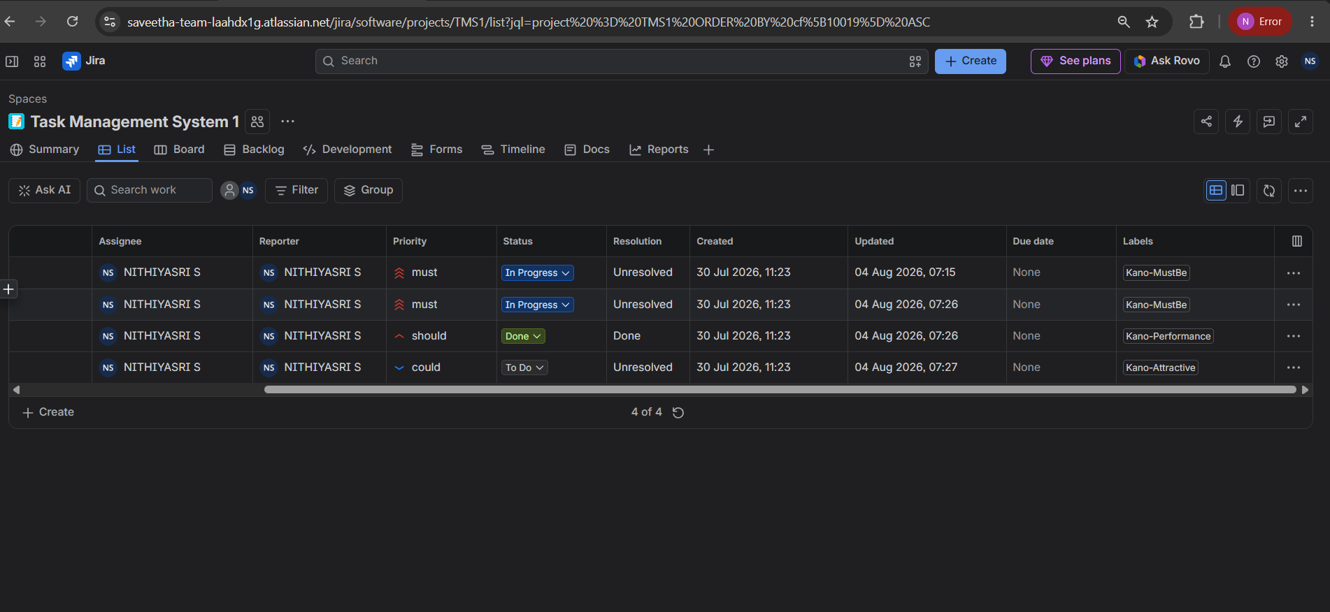

Result
The requirements for the Task Management System were successfully structured, categorized, and prioritized using both the MoSCoW and Kano models in Jira.

Exp No 5: Requirement Prioritization for an Online Learning Platform using MoSCoW and Kano Models
Aim
To prioritize and categorize the functional requirements of an Online Learning Platform using the MoSCoW and Kano models in Jira for effective project planning, scope definition, and customer satisfaction management.
Procedure
- Project Setup:
  - Logged in to Jira Software and created a new project named Online Learning Platform.
- Requirement Creation:
  - Created the following six core functional requirements as Jira issues:
    - Course Enrollment and Registration
    - Video Lecture Streaming
    - Interactive Quizzes and Assignments
    - Progress Tracking Dashboard
    - Peer-to-Peer Discussion Forums
    - Certificate Generation
- Sprint Backlog Setup:
  - Opened the Backlog section and added all six work items to Sprint 1.
- MoSCoW Prioritization (Via Jira Priority Field):
  - Updated the Priority field of each task in Jira based on system reliance and urgency:
    - Must Have (must): Course Enrollment and Registration, Video Lecture Streaming
    - Should Have (should): Interactive Quizzes and Assignments, Progress Tracking Dashboard
    - Could Have (could): Peer-to-Peer Discussion Forums, Certificate Generation
- Kano Model Classification (Via Jira Labels):
  - Assigned custom Labels to each requirement to map customer satisfaction categories:
    - Basic Needs (Kano-MustBe): Course Enrollment and Registration, Video Lecture Streaming
    - Performance Needs (Kano-Performance): Interactive Quizzes and Assignments, Progress Tracking Dashboard
    - Excitement / Delighter Needs (Kano-Attractive): Peer-to-Peer Discussion Forums, Certificate Generation
- Task Assignment & Verification:
  - Assigned all six tasks to the team member (NITHIYASRI S) and verified the finalized priorities and labels across the List view and Board view in Jira.

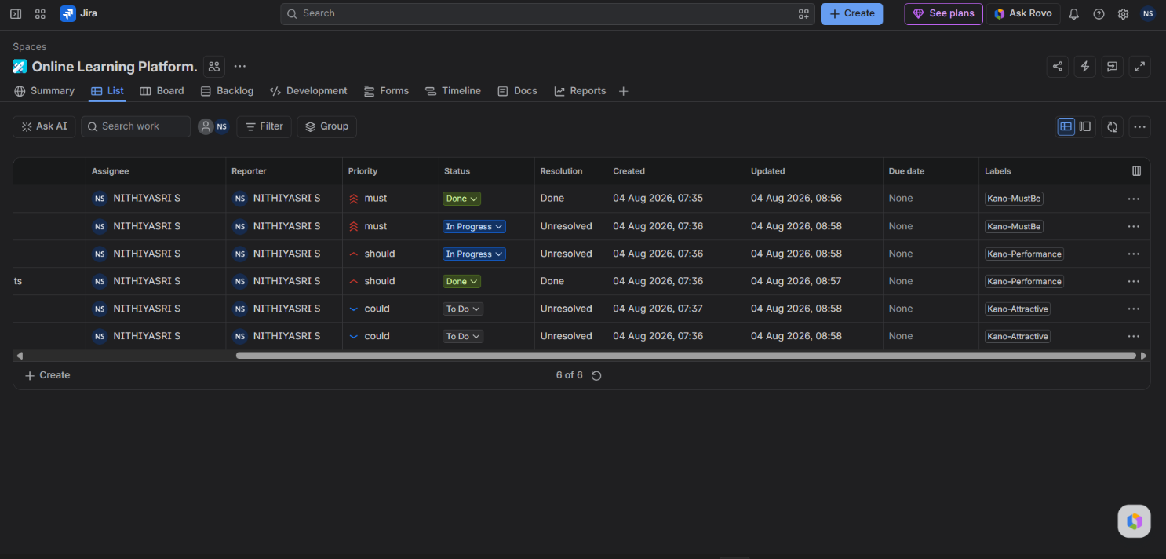

Result
The functional requirements for the Online Learning Platform were successfully created, prioritized, and organized in Jira using both the MoSCoW and Kano frameworks.

